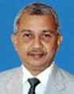
Shri T. Ramachandru, IAS
Principal Secretary,
Industries Department
Government of Orissa
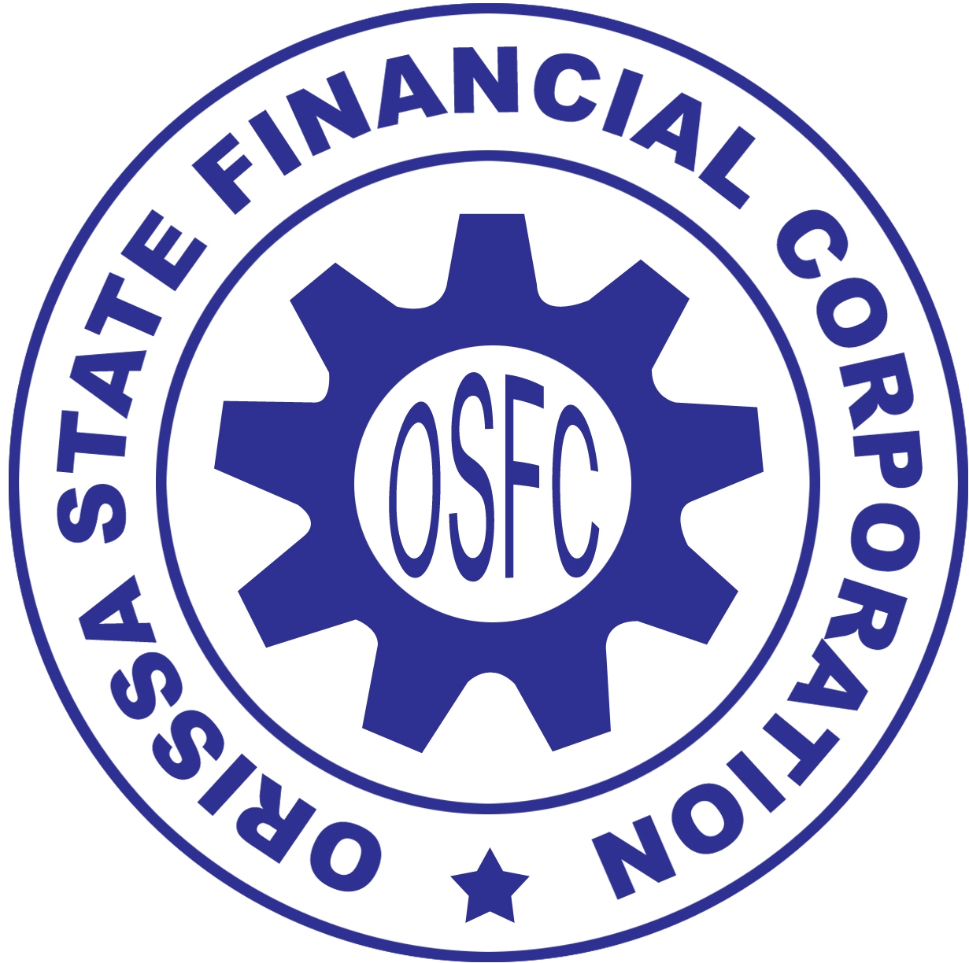

54th

ANNUAL GENERAL MEETING

29th July, 2011

ORISSA STATE FINANCIAL CORPORATION
OMP SQUARE, CUTTACK 753003

website: www.osfcindia.com
Email: osfcho@osfcindia.com

Ladies and Gentlemen,
A very good morning to all of you. It is my pleasure to extend you all on behalf of the Board of Directors of Orissa State Financial Corporation (OSFC) a very warm and cordial welcome to the 54th Annual General Meeting (AGM) of shareholders. Today, I stand before you for the first time after taking over as the Chairman of OSFC on 11th July 2011.
The copies of Annual Report on the working of the Corporation together with Audited Accounts & Auditor’s Report thereon for the financial year ended 31st March 2011 are already before you and with your permission, I shall take them as read.
Economic Scenario
The Indian economy has displayed remarkable growth during FY 2010-11. The Gross Domestic Product (GDP) growth rate was estimated at 8.6% as compared to 8% during previous year. The robust growth rate was driven by the outstanding performance of industrial sector and service sector. At home, the State economy has shown significant growth in recent years. The Net State Domestic Product (NSDP) has increased from `38399 crore on 1999-2000 to `134241 crore in 2009-10 recording annual growth rate of 12.65%. The service sector accounted for about 54% of Gross State Domestic Product (GSDP) followed by exposure of Industries and Agriculture of 28% and 18% respectively. The advance to MSME sector by banks under Annual Credit Plan 2010-11 in the State stood at `9904 crore which constitutes 14.27% of the total advance.
Performance of OSFC
Your Corporation, in existence for more than five decades, has fuelled industrialization in the State and has fulfilled some of the major socioeconomic obligations of state like entrepreneurship development, employment generation and inclusive growth across region and population, besides contribution to development of critical infrastructure and export earnings.

The strength of your Corporation lies in its network of Branches, experienced manpower and commitment to the cause of MSMEs. The State Government by deciding to restructure and revive the Corporation is providing necessary support to run it as a true financial institution. The top management and Board of Directors which are strengthened by professionals, have taken several initiatives during the year to remove bottom-line deficiencies in policies, procedures and practices to enable the Corporation to march ahead in the competitive environment. Going forward, constant hunt for business opportunities, creating healthy loan portfolio, customer satisfaction, financial sustainability, manpower reorientation & reskilling and developing strong technology platform would be its thrust areas.

The new Loan Policy adopted by the Corporation lays emphasis on providing credit assistance to new industries like hotels at strategic locations and in places of tourist importance, nursing homes , industrial clusters, IT and ITES projects, food processing units and export oriented units in line with the Industrial Policy of the Government.
Business initiatives
During the year under review, the Corporation has taken several measures covering policy, procedure, practice, manpower motivation, orientation, accountability and computerization etc with a view to enable your Corporation to function as a true financial institution in a competitive business environment. Though the Corporation is handicapped being a single product term lending institution, it would draw inspiration from some of the well-run SFCs, particularly in South, and model its growth with the active support of State Government and SIDBI. Some of the key areas addressed during the year are as under:
- Formulated Loan Policy FY 2011-12 to broad base and scale up its operation in order to create healthy loan portfolios.
- Introduced a comprehensive Loan Recovery Policy wherein post disbursement monitoring, NPA monitoring and management have been emphasized in order to prevent slippage of standard accounts.
- Adopted Credit Appraisal and Rating Tools (CART) software of SIDBI for appraisal and risk rating of credit proposals up to `1.00 crore.
- Made tie-up arrangement with Union Bank of India to facilitate sanction of Working Capital.
- Initiated process of joint financing with SIDBI for sharing risk.
- Initiated periodic Business Review Meetings with the Branch Managers and Heads of Departments to review the performance as well as identify the weak areas for improvement.
- Introduced Staff Accountability Policy.
- Formulated Document Management Policy for weeding out the old records.
- Formulated the Technology Up-gradation Scheme as per the “MSME Development Policy 2009” which is under consideration of the State Government.
- Took active participation in the 7th Entrepreneurs’ Week (05 – 11 March 2011) organized by the State Government throughout the State.
Your Corporation has set a business target (Sanction) of `50 crore for FY 11-12 which has been allocated to Branches, the progress of which is being monitored regularly.
Sanction
Your Corporation remained away from business of lending for over six years during which most of the good customers of the Corporation migrated to Banks and other Financial Institutions. The loan policy for FY 2010-11 laid emphasis on financing only standard units which did not yield satisfactory response. The Corporation could sanction only `3.94 crore to six units. The cumulative sanction since inception stood at `1310.20 crore.
Disbursement
The Corporation disbursed `0.71 crore during the year under report to three units. The cumulative disbursement since inception stood at `1305.83 crore.
Recovery
During the year under report, the Corporation has recovered `42.03 crore which was higher than `40 crore during previous year. The cumulative recovery since inception stood at `1887.39 crore.
Fee based activities
The Corporation has undertaken fee based activities like General Insurance business, preparation of project profiles and training support for entrepreneurship development to augment its income.
Financial result
The Corporation has earned net profit consecutively for the last six years and the net profit during the year 2010-11 stood at `0.61 crore. The dip in net profit from `1.80 crore in the previous year is mainly on account of lower interest income and higher personnel expenses during the year under report. The net-worth and Capital Adequacy Ratio (CAR) as on 31.03.2011 stood at `16.57 crore and 10.89 percent respectively.

Restructuring of OSFC
The financial and organizational restructuring of your corporation which was approved by the State Cabinet during December 2006 and February 2009 is nearing completion. The following pending issues are yet to be addressed.
- Approval of State Government under Section-4(2) and Section-4(3) of SFCs (Amendment) Act 2000 for allotment of Shares in favour of SIDBI and IDBI Bank on account of :-
- Conversion of Loan-in-Lieu of Share Capital (LISC) of `6.225 crore plus interest from 01.04.2008 till the date of actual conversion to ordinary Share Capital.
- Conversion of unpaid dividend of `25.48 crore to ordinary Share Capital.
- Waiver of interest by SIDBI on LISC amounting to `7.42 crore (since inception till 31.01.08) and waiver of funded interest.
- Support from SIDBI to assist capacity building project of OSFC.
The Corporation is committed to high level of ethical standards in terms of its policies, procedures and delivery mechanism and has adopted Corporate Governance Policy as prescribed by the State Government for PSUs.

Acknowledgement
Before I conclude, I would like to take this opportunity to thank everyone associated with the Corporation, particularly, our esteemed stakeholders and our valued customers for their continued trust and confidence. I on behalf of the Board of Directors and myself would like to place on record the deep appreciation and the valuable services rendered by Mr. P.R.Das, Ex-Chairman and Mr. K.N.Khatai, IAS, Ex-Managing Director, OSFC and Mr. B.K.Tripathi, Sr. Divisional Manager, LIC of India, Mr. D.P.Mohanty, Special Secretary to Government, Shri B.K.Samal, Additional Secretary to Government, as Directors. I would like to express my deep appreciation to all the Directors on the Board for their valuable service, co-operation and support.
I express my sincere gratitude to the Government of Orissa and SIDBI for their continuous support and guidance. I also thank the officers and staff of the Corporation who have put in their best efforts in making the Corporation more responsive to the needs of the clients. I believe the prospect of the Corporation lies in ensuring the prosperity of its valued customers. It will be our earnest endeavour to develop a customer friendly approach coupled with effective and speedy credit delivery mechanism to pave the way for turn around.
I express my deepest thanks for attending this Annual General Meeting and hope that your Corporation will continue to have your co-operation in years to come. I now place the Balance Sheet, Profit & Loss Account of your Corporation along with the Directors’ Report for your consideration.

T. Ramachandru
C H A I R M A N

